

Requirements for Making Accessible PowerPoint 2010 Documents at the U.S. Department of Education

January 2012
Version 1.0


Requirements for Making Accessible PowerPoint 2010 Documents at the U.S. Department of Education

Assistive technology is used by individuals to help them understand electronic information. For example, screen readers or text-to-speech software is one tool available and assists individuals who are blind, have low vision, or a learning disability. This special technology interprets words on the page and translates them to a computerized voice that reads the information. You may have heard the name JAWS or Window-Eyes as these are some examples of this assistive technology. Accessible documents work in partnership with assistive technology to ensure individuals with disabilities have access to information.
Listed below are basic PowerPoint 2010 Requirements that help make documents accessible and come from Section 508 of the Rehabilitation Act. The Department has identified fourteen requirements that are divided into four major categories:
- Document Layout and Formatting,
- Document Images,
- Document Tables, and
- Other.

These fourteen requirements are further organized into “Do” and “Do Not” categories to help with clarity. The majority of these requirements provide an underlying technical structure so that they can be used effectively by assistive technology. When you create an accessible document, you are using methods that make a document usable by individuals with any type of disability. A little change on your part to use built-in features makes a big difference for individuals with disabilities.
PowerPoint 2010 has a built in accessibility checker. However, the rules in the accessibility checker do not match the requirements at the Department. Therefore, the checker can be helpful in identifying some issues (i.e., missing alternative text, etc.), but a document will not be considered accessible until it adheres to all the requirements listed below.

Document Layout and Formatting

DO:

Do use built-in features of PowerPoint 2010 to encode a structure and layout that can be used by assistive technology.
Documents should be created using built-in formatting to create the underlying technical structure that allows assistive technology to work properly. The use of these built-in features allow individuals using assistive technology to navigate through documents quickly and efficiently. The next six sub-points identify common built-in features that assist with structure.

Predefined Slide Layouts
When creating presentations, use the nine predefined slide layouts available in PowerPoint 2010. Using these predefined layouts will help make the content more accessible and easier to convert to other formats (i.e., braille).
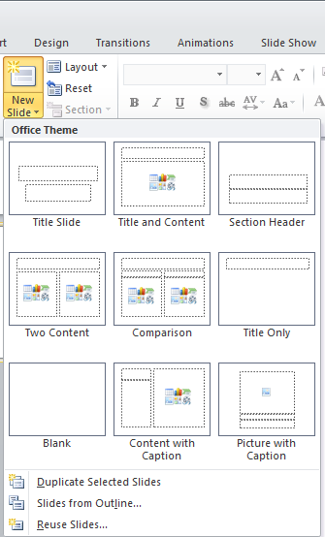

Lists
When creating documents with lists, use the Bullet, Numbering, or Multilevel lists command under the Home tab paragraph section; do not manually type characters or numbers.

Page Numbering
When adding page numbers to a document, use the page numbering codes under the Insert tab Header & Footer section; do not manually type characters.

Tables
When creating documents with tables to create a tabular structure, use the built-in table command under the Insert tab Table section. Do not use tabs, spaces or draw table to display columns and rows of information.
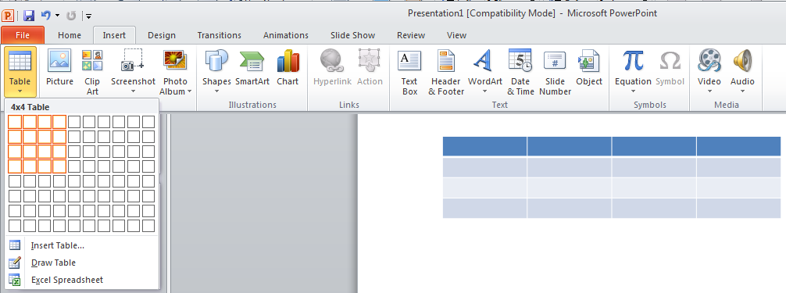

Charts
When creating documents with charts, use the built-in chart command under the Insert tab Chart section.
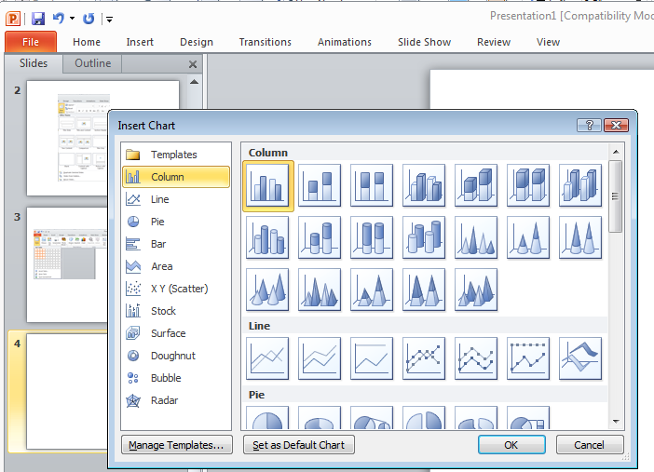

Headers and Footers
Assistive Technology cannot easily read information imbedded into Power Point 2010 headers and footers; therefore, it is important to only put redundant information in these locations. For example, if the Title of the Document is listed on the First page and the author wants to put it in the footer so that is shows on every page that is fine because it’s redundant information. However, if the author wants to put the Department web address and address in the footer and it’s not listed anywhere else in the Document, this is not acceptable as it does not create a comparable document.

Do check to ensure for proper reading order.
Ensure the content on the slide follows proper reading order. To check this, click on the slide and press tab. The tab will present the reading order. For example, in the slide listed below, if the tab highlights “I came,” “I concurred,” and then “I saw,” the reading order is not proper and must be adjusted until the tabs highlight the correct reading order of “I came,” “I saw,” and “I concurred.” The reading order is determined by the order in which the text boxes were created and therefore adjusting the slide requires rebuilding it and building the components in the appropriate order.
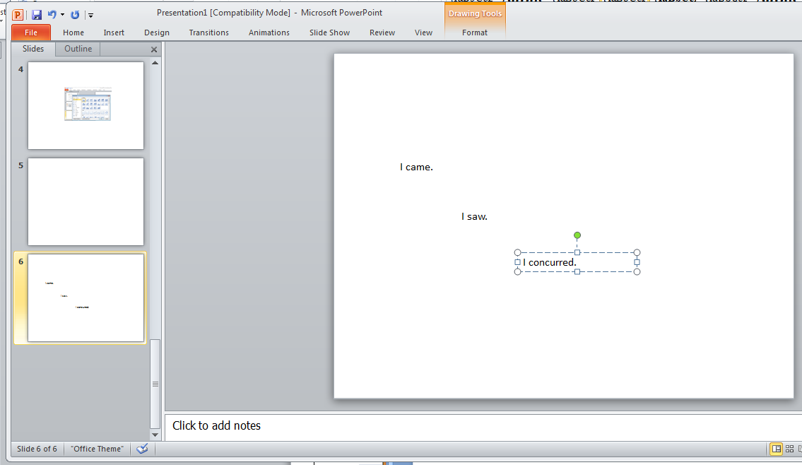

Do ensure all links work (are linked to active Web destinations).

DO NOT:

Do not rely on color-coding as the only means of conveying information or distinguishing a visual element.
Color is useful in conveying important information. However, when color alone is used to convey meaning (i.e., making a section of text red), then a person who is blind or colorblind will not have access to the information. Therefore, color alone will not make information accessible. A remedy would be to use color and another indicator.

An Example of using color and another indicator
Below is a list of participants with the winner denoted with * and highlighted in red.
Ann Jones
Jim Cane*
Janis Poole

Do not rely on sound as the only means of conveying information.
Presentations containing an audio file should have a text description or transcript as part of the slide. A text description will benefit a user who is deaf or hard of hearing. If the PowerPoint 2010 presentation contains a video, the captioning must be synchronized with the video.

Do not use blinking text, objects, or other elements having a flash or blinking frequency between 2 Hz and 55 Hz.
Blinking text, objects, or other elements that have a flash or blinking frequency in this range may cause seizures in individuals with photosensitive epilepsy and may be distracting to individuals with learning disabilities. Therefore, these frequencies should not be used.

Document Images

DO:

Do provide a text equivalent for every non-text element.
Documents are usually a combination of text and non-text elements (i.e., images, photos, charts, graphical text or audio files). Because a screen reader cannot read a non-text element, it is important to include text equivalents so that people using assistive technology have access to the graphical elements. Text equivalents are referred to as “alt text” or alternative text that describe the information in a non-text element. Right click on the border of the non-text element and then click on Size and Position.

Examples of Equivalent Text for a Non-Text Element
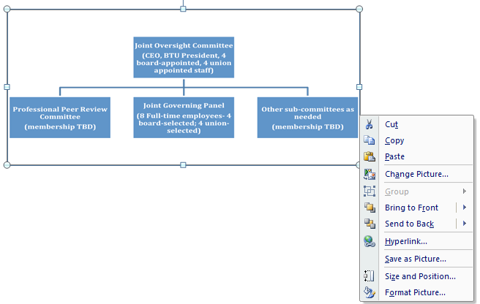
Click on the “Alt Text” tab and type in text that describes the non-text element and select Close.
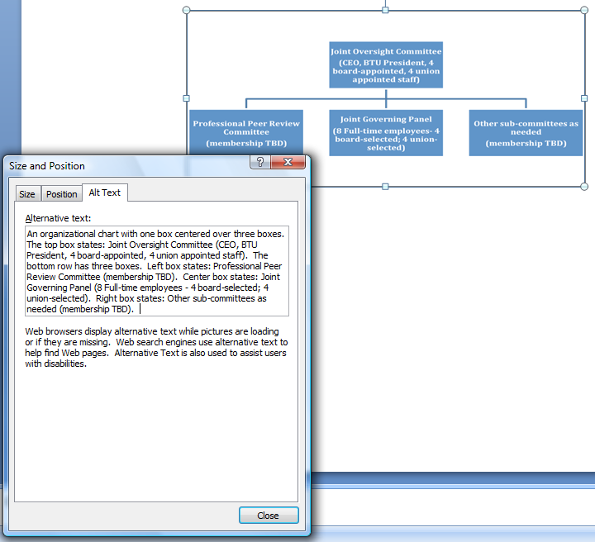

Do group multiple associated images as one object (i.e., Organizational Charts) and use one alternative text (alt tag) for the image.
When creating a document image with multiple associated images, instead of providing an alternative text for each individual component, you must group the images together and then provide one alternate text for the whole image.
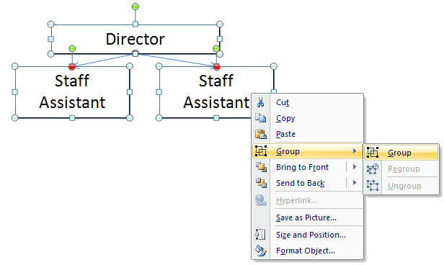

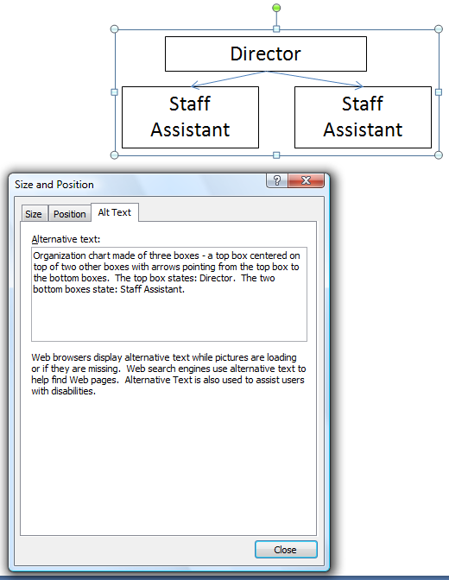

Do ensure that complex images, diagrams or charts have descriptive text in the notes pane or in an appendix.
When creating a complex image, diagrams or charts, it may not be possible to create an alternative text that sufficiently describes the object. Therefore, it is necessary to provide descriptive text in the notes pane or in an appendix. See the example below.

Example Figure 2:
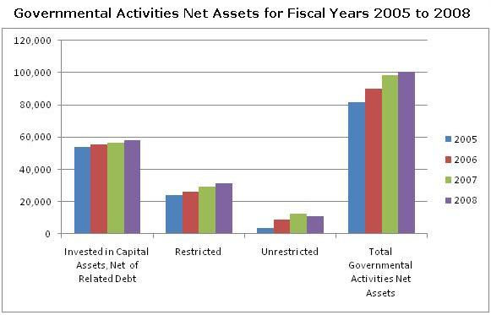

The table below shows the data for Governmental Activities Net Assets for Fiscal Years 2005 to 2008 with amounts in millions of dollars:
GOVERNMENTAL ACTIVITIES | 2005 | 2006 | 2007 | 2008
Invested in Capital Assets, Net of Related Debt | 53,815 | 55,473 | 56,438 | 58,208
Restricted | 24,110 | 25,993 | 29,347 | 31,358
Unrestricted | 3,753 | 8,696 | 12,565 | 11,105
Total Governmental Activities Net Assets | 81,678 | 90,162 | 98,350 | 100,671

Do turn animations and transitions off before posting to the web.
Do not use animations or transitions in documents posted to the web. Ensure they are turned off by selecting none under the Animations or Transitions tab.
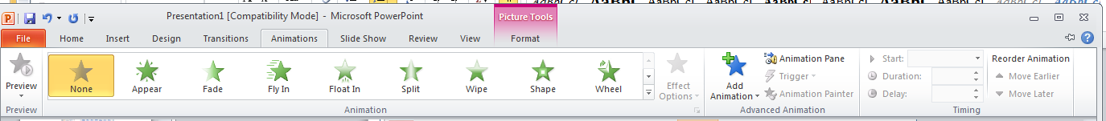
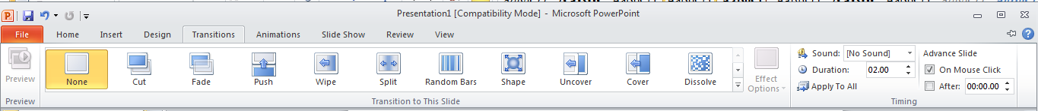

Document Tables

DO:

Do ensure that tables containing ‘data’ have the first row designated as a ‘Header Row’ in Table Style Options.
You identify the Header Row highlighting the top row of the table, selecting the “Design” tab and placing a check in the checkbox for “Header Row” in Table Style Options.
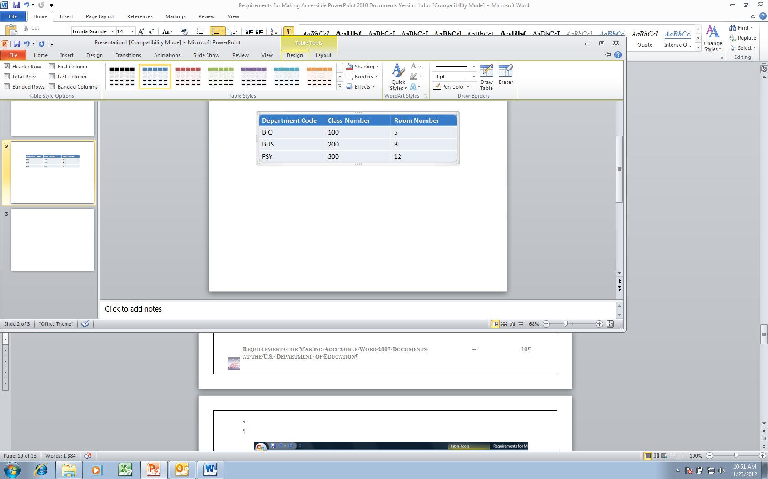

Do describe and label tables and charts when appropriate.
There are various ways to describe and label a table. The example below shows a title inserted above the table.
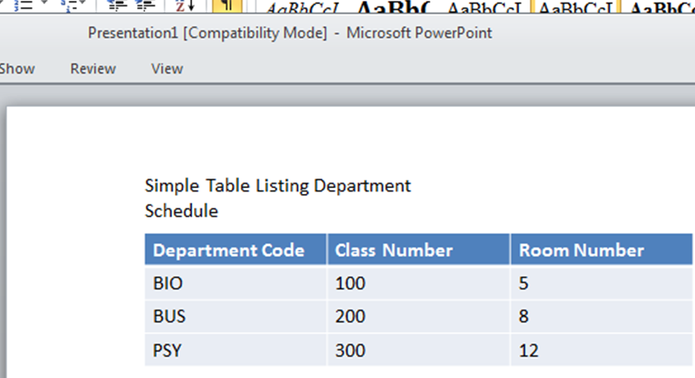

DO NOT:

Do not create tables with merged or split cells or with multilevel headings. Do use mark-up to keep row and headers associated with the right data cells in simple data tables.
A data table is a grid that contains a set of related information laid out in rows and columns with headers at the beginning of the columns and/or rows. Visually, data tables are easy to understand because a sighted user can scan up to the top of the column or the beginning of the row to read the column and row headers for any data cell in the table. Individuals using a screen reader rely on the software to announce the column or row headers. Therefore, it is important to identify the headings in a table so that a screen reader will be able to clearly match which heading relates to a data cell. However, because of the constraints of current technology, only simple tables can be made accessible in Word and PowerPoint. More complex tables might be made accessible by conversion and remediation to PDF.
Figure 2: An example of an inaccessible table in Word and PowerPoint (not simple)
Dept Code | Class # | Section | Max Enrollment | Room # | Days | Instructor
BIO | 100 | 1 | 15 | 5 | Mon, Wed, Fri | Warren
BIO | 100 | 2 | 15 | 6 | Tue, Thu | Thomas
BUS | 150 | 1 | 15 | 13 | Mon, Wed, Fri | Halden
BUS | 210 | 1 | 10 | 13 | Mon, Wed, Fri | Jones

Figure 3: An example of an accessible table in Word or PowerPoint (simple)
Dept Code | Class # | Section | Max Enrollment | Room # | Days | Instructor
BIO | 100 | 1 | 15 | 5 | Mon, Wed, Fri | Warren
BIO | 100 | 2 | 15 | 6 | Tue, Thu | Thomas
BUS | 150 | 1 | 15 | 13 | Mon, Wed, Fri | Halden
BUS | 210 | 1 | 10 | 13 | Mon, Wed, Fri | Jones

Other

DO:

Do provide an alternative format, with equivalent information and functionality, if a document cannot be made accessible. This option should be used as a last resort.
Following these basic requirements will increase the accessibility of your documents, but it does not guarantee accessibility to any specific disability groups. In cases where more certainty is required, it is recommended that you test the office documents with end users with disabilities, including screen reader users, or send to the Assistive Technology Team for testing.
While basic requirements have been provided, more complex projects may have additional standards applied such as the technical standards in Section 508 in 1194.21, 1194.22, and 1194.31. This document sets out basic requirements on making Power Point 2010 documents accessible. We will continue to work on improving this document to make it even more user-friendly and ensure that it provides the most thorough and up-to-date information possible. Any feedback that you have on possible improvements would be appreciated and can be sent to Holly.Anderson@ed.gov.

This document has been a team effort. A huge thank you to everyone on the development team: Don Barrett, OCIO; Crystal Jones, OCIO; Terri Youngblood, OCIO; Christopher Coro, OVAE; and Jim Richards, Training and Development.

